## Create Lambda Function

### Go to dashboard and create the function

### 

### Name your function something descriptive. We’ll be using Python 3.10 (because I said so)

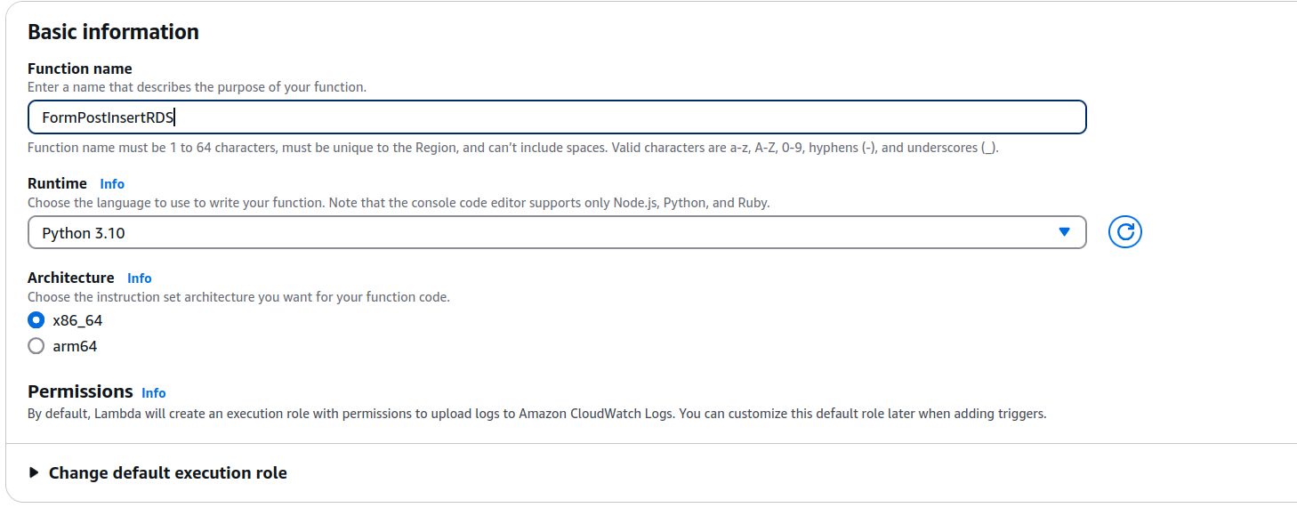

### For additional configurations, enable function url for the function to get a public url. Disable authentication for it.

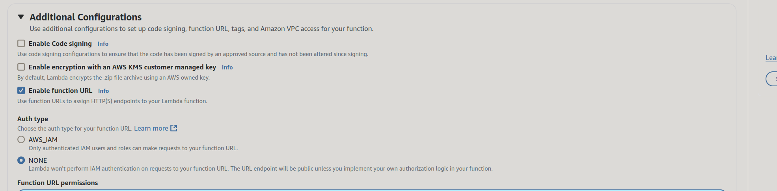

### Create the function

### Upload the zip layer attached

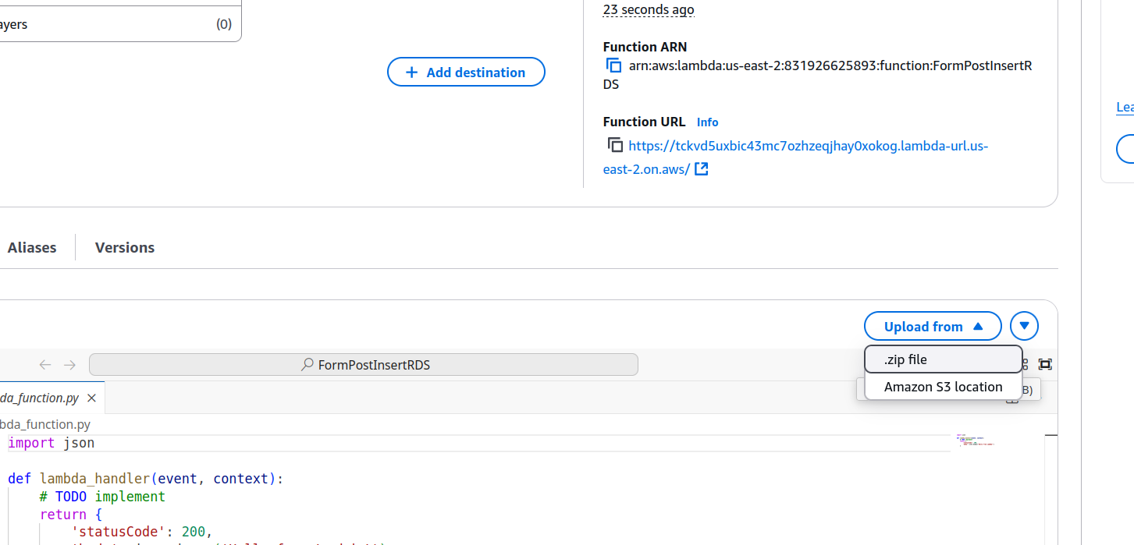

### 

## Changing configurations

We need to change several configurations to make it work with our database

### Timeout

Change the timeout to 30 seconds, so that the function has time to make a connection

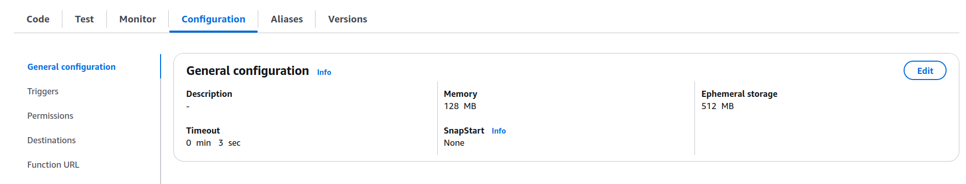

### Environment Variables

This is the same as your .env file that you created. This will store the credentials to access the database.

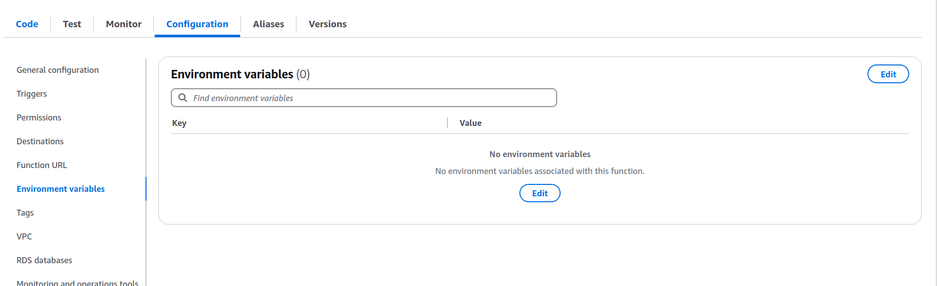

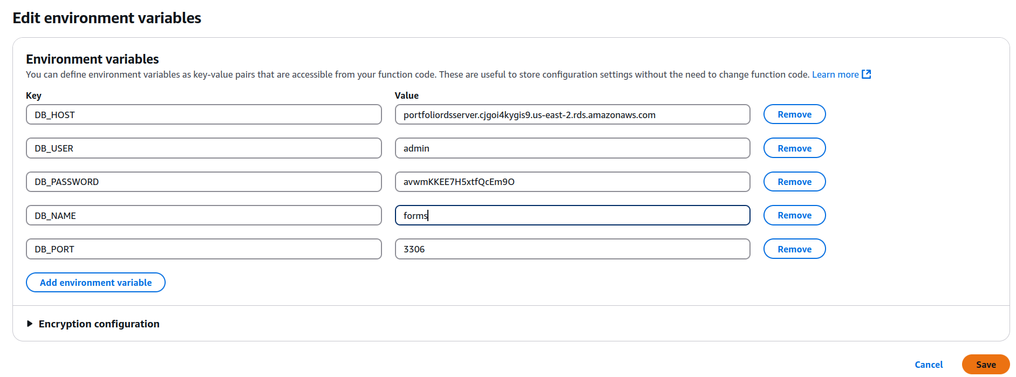

### RDS Database Network Connection

We need to connect the database and the function with a network connection.

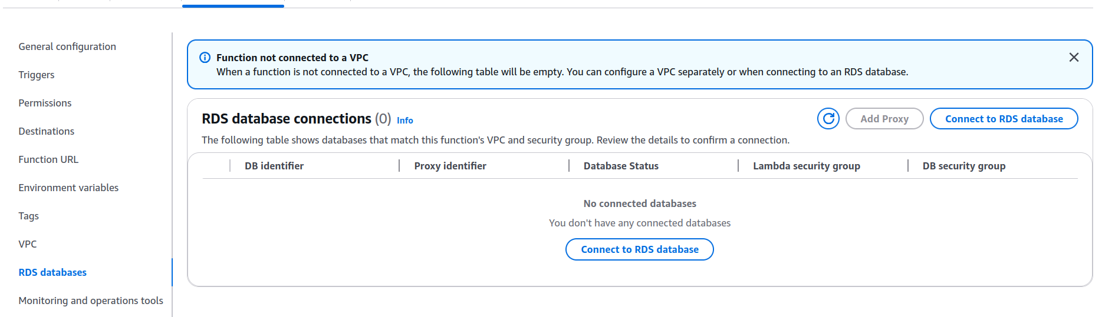

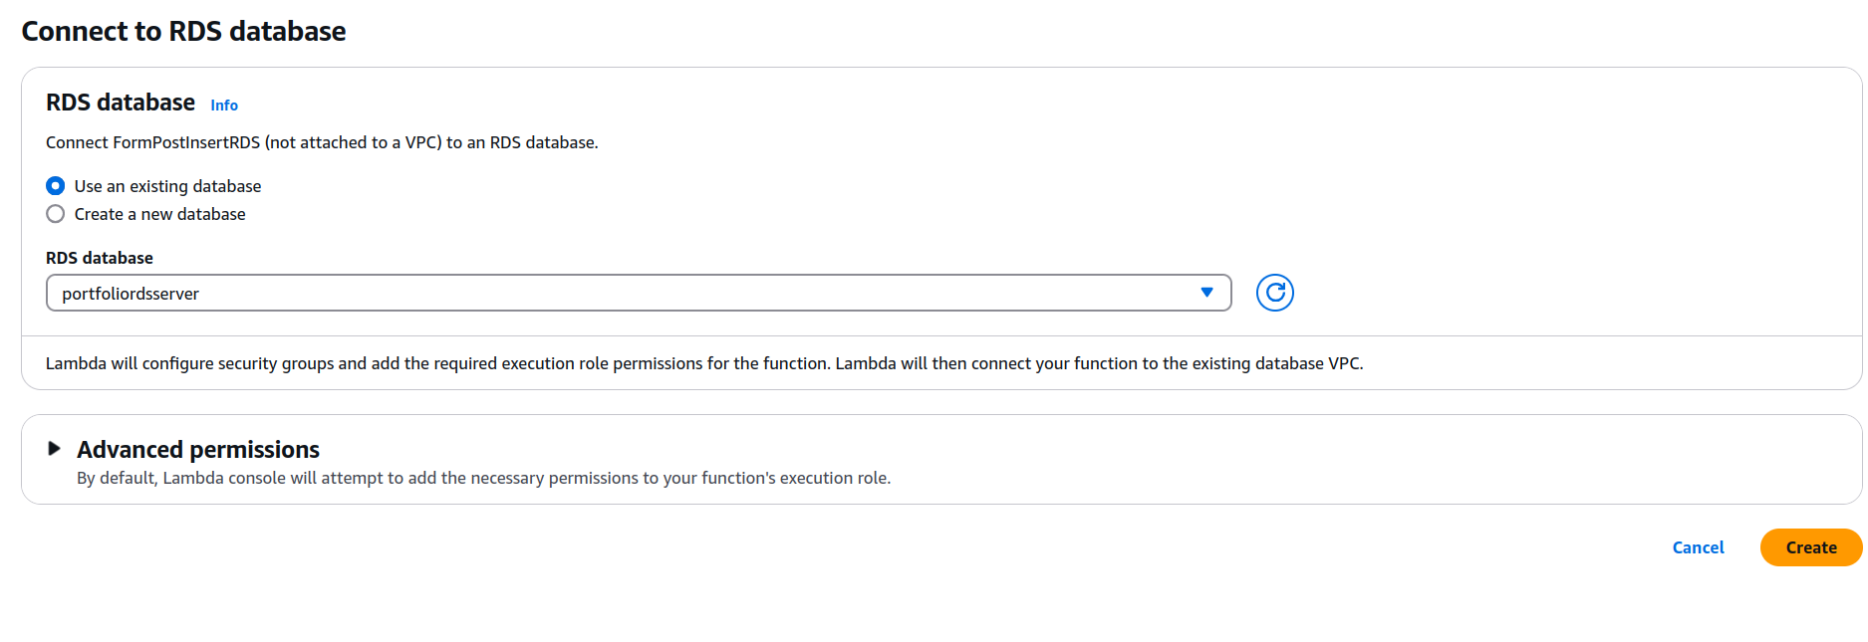

## Add some test events

### Create a successful test

{

"httpMethod": "POST",

"body": "{\"name\":\"Test User\",\"email\":\"test@example.com\",\"subject\":\"Test Subject Line\",\"message\":\"This is a test message\"}"

}

Put in JSON and then save

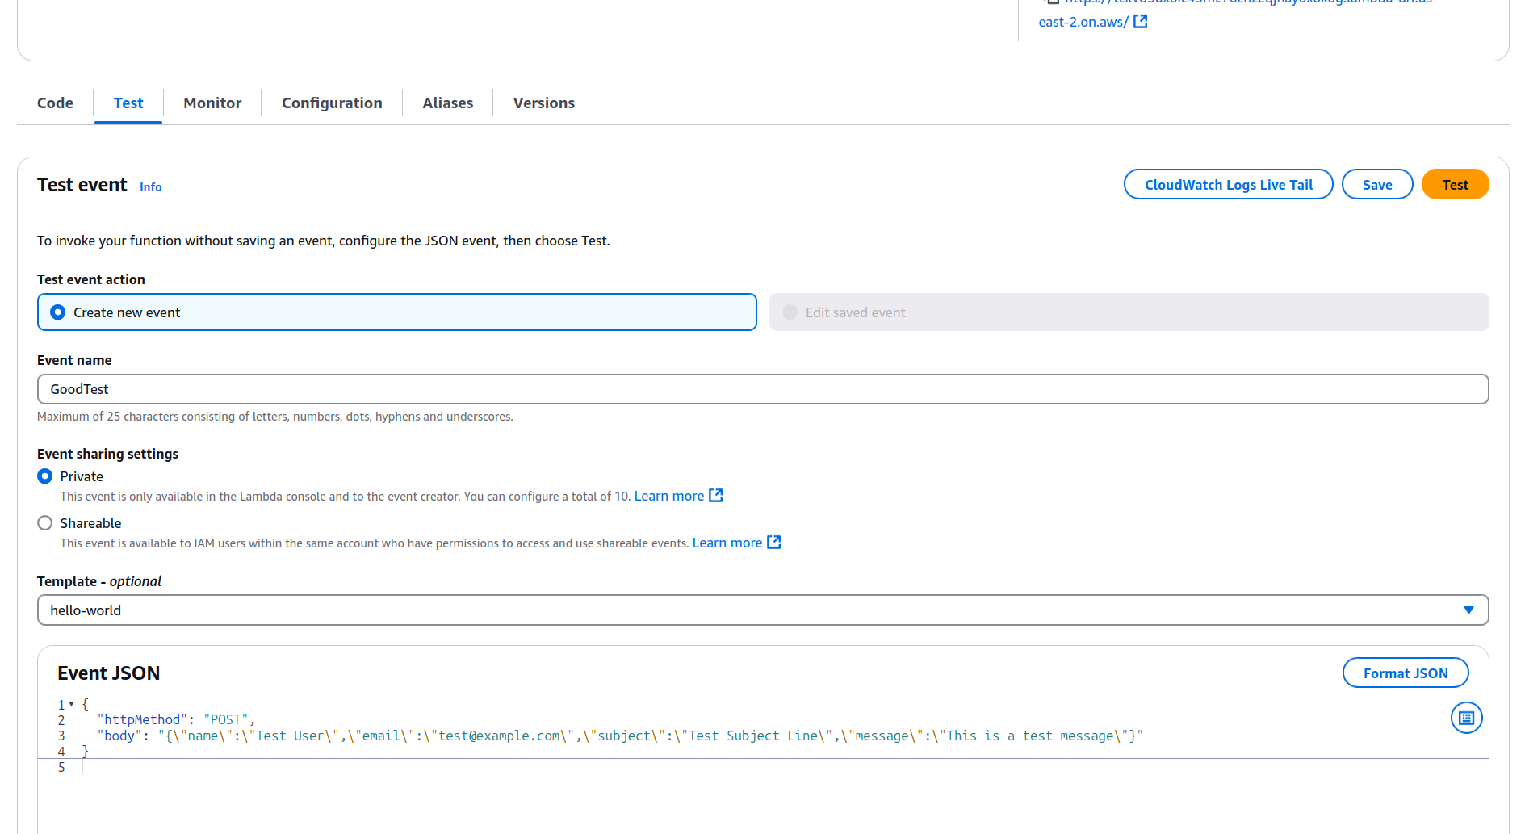

### Create some bad tests

{

"body": "{\"name\":\"Test User\",\"email\":\"test@example.com\",\"message\":\"This is a test message\"}"

}

Put in JSON and then save

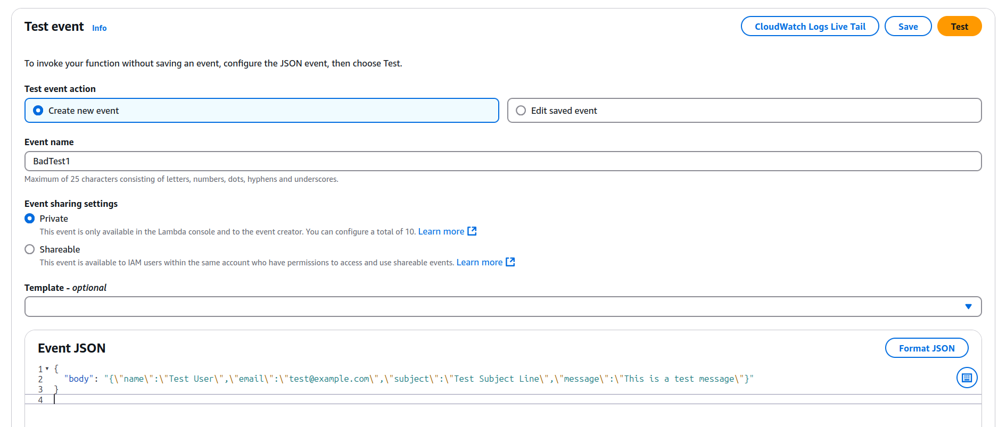

## Run your function

### Deploy your code.

The function is not updated until you deploy your code to it. **Press ctrl+s on the py file to save it**, then press deploy

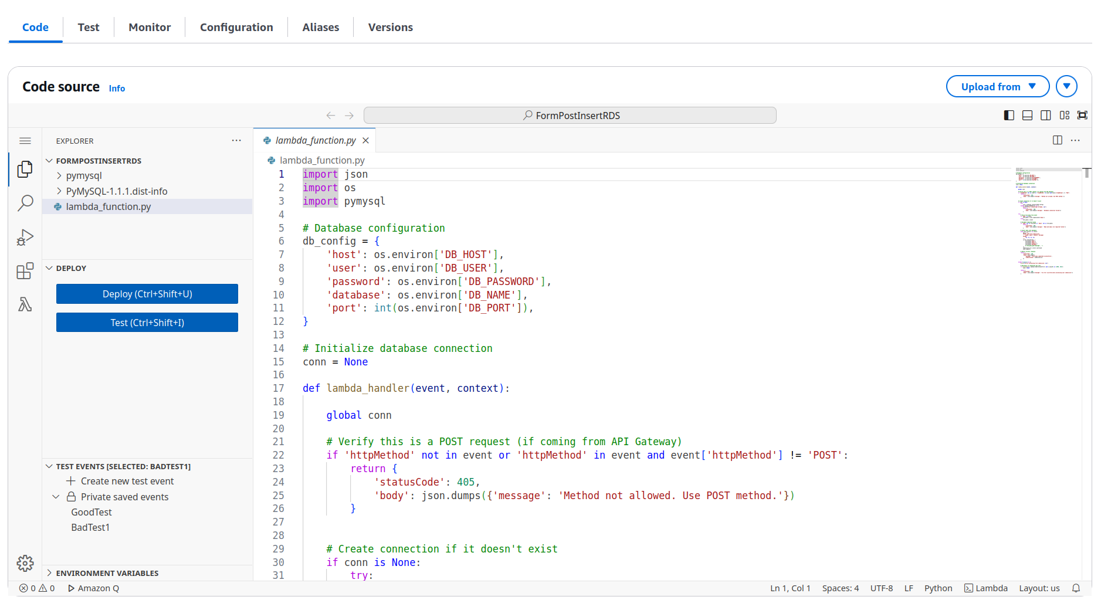

### Run the tests

Press the play button on your saved tests

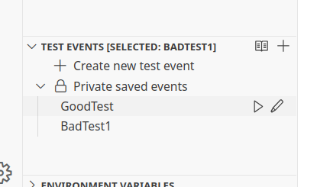

You should get outputs like this

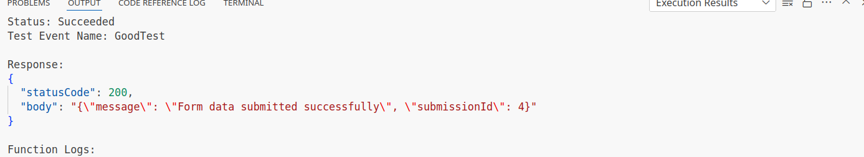

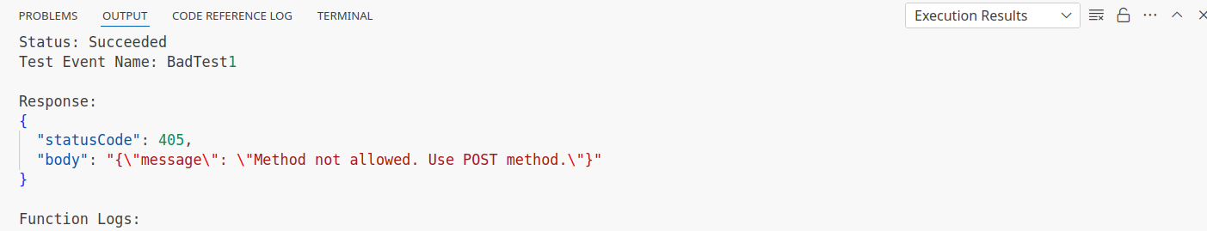

### Try the public link

Try going to your public url now to test it

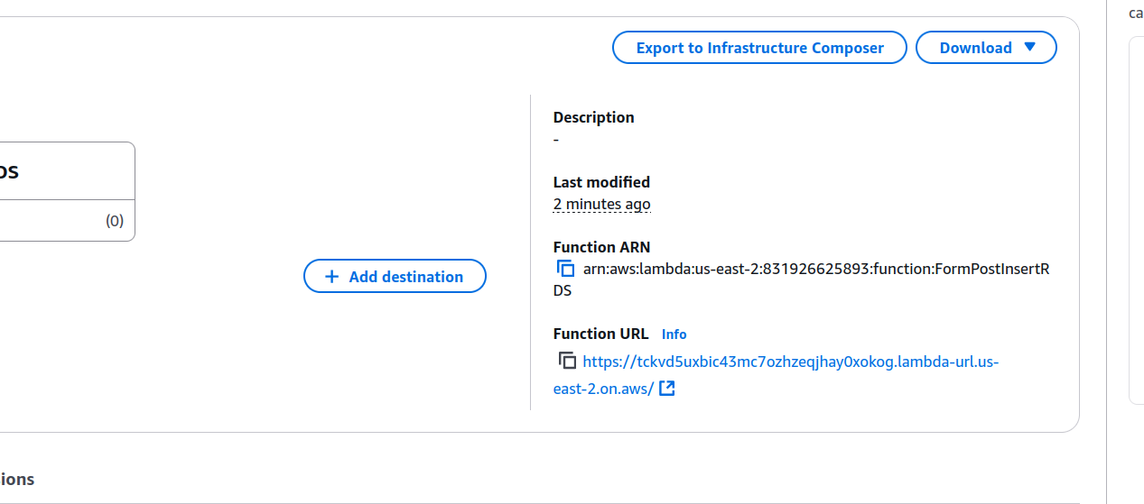

Because we’re using a get request, it won’t work.

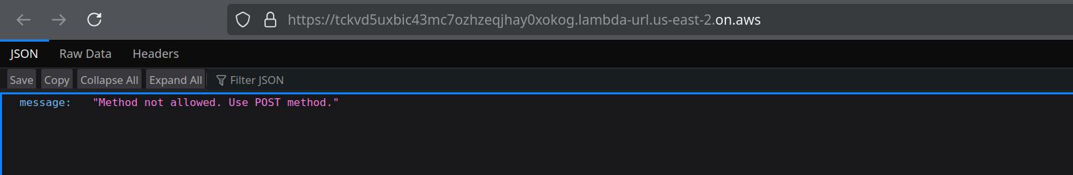

### Now add it to your website.